Generating and Approximating Nondominated Coteries
Jan C. Bioch, and Toshihide Ibraki
IEEE TRANSACTIONS ON PARREL AND DISTRIBUTED SYSTEMS, VOL. 6, NO. 9, SEPTEMBER 1995 pp.905-914
Abstract
In this paper, we introduce an operator ρ, which transforms a positive self-dual function into another positive self-dual function. We propose a simple algorithm to check whether a given positive function is self-dual or not. Finally, we present a incrementally polynomial algorithm that generates all positive self-dual functions (ND coteries) by repeatedly applying ρ operations. Based on this algorithm, all ND coteries of up to seven variables are computed.
- 1.Introduction
- Definitions and Basic Properties
f^{d}(x)=f(x) where f, x denote the complement of f and x.
1.A function is called dual-minor if f ≤ f^{d}
2.dual-major if f ≥ f^{d}
3.self-dual if f = f^{d}
e.g. f=123 is dual-minor since f^{d}=1+2+3 satisfies f ≤ f^{d}
- g. f=12+23+31 is self-dual since
f^{d}=(1+2)(2+3)(3+1)=12+23+31
- The Operator ρ and Its Properties
T(ρ_{w}(f))=(T(f)\{w})∪T(w)
- g.
f=12+13+145+234+235
ρ₁₂(f)=345+12(3+4+5)+13+145+234+235
=124+125+13+145+234+235+345
ρ₂₃₄(f)=15+234(1+5)+12+13+145+235
=12+13+15+235
- Almost-Self-Dual Functions
A function f is called almost-self-dual function if f^{s}≤f≤f^{d}
- g. f=12+13+145+234+235
f^{s}=345(1+2)+245(1+3)+23(1+4+5)+15(2+3+4)+14(2+3+5)
=123+124+125+134+135+145+234+235

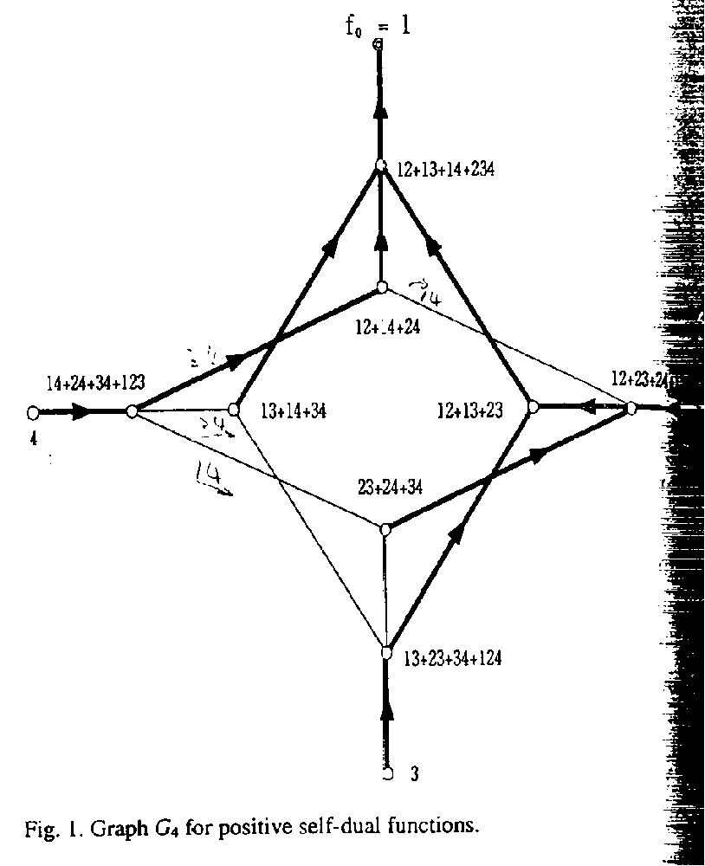
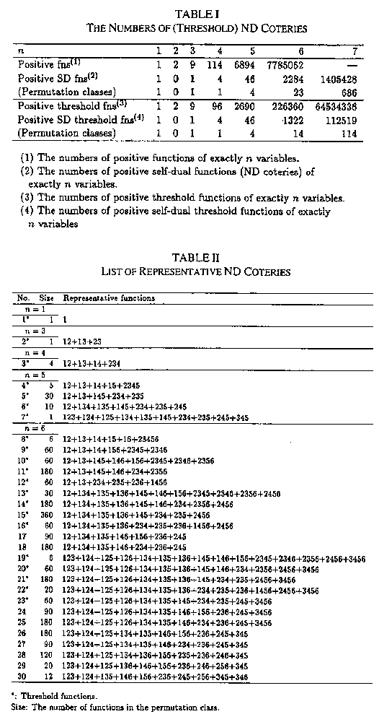
Created by : Kwo-Tsung Tseng
Date : August 7, 1998

